

COMSATS UNIVERSITY ISLAMABAD, ABBOTTABAD CAMPUS

DEPARTMENT: SOFTWARE ENGINEERING (BSE).

SUBJECT: OO SOFTWARE ENGINEERING.

SECTION: 4D.

SUBMITTED TO: SIR JAWAD KHAN.

SUBMITTED BY:

|  |  |  |
| --- | --- | --- |
| SERIAL NO. | NAME | REGISTRATION NUMBER |
| 01. | MARIA MANZOOR | FA20-BSE-161 |
| 02. | ZAKIR FAYYAZ | FA20-BSE-166 |
| 03. | RIZWAN SHAH | FA20-BSE-167 |

**Project name: Health Care Management**

**Use Case Diagram:**

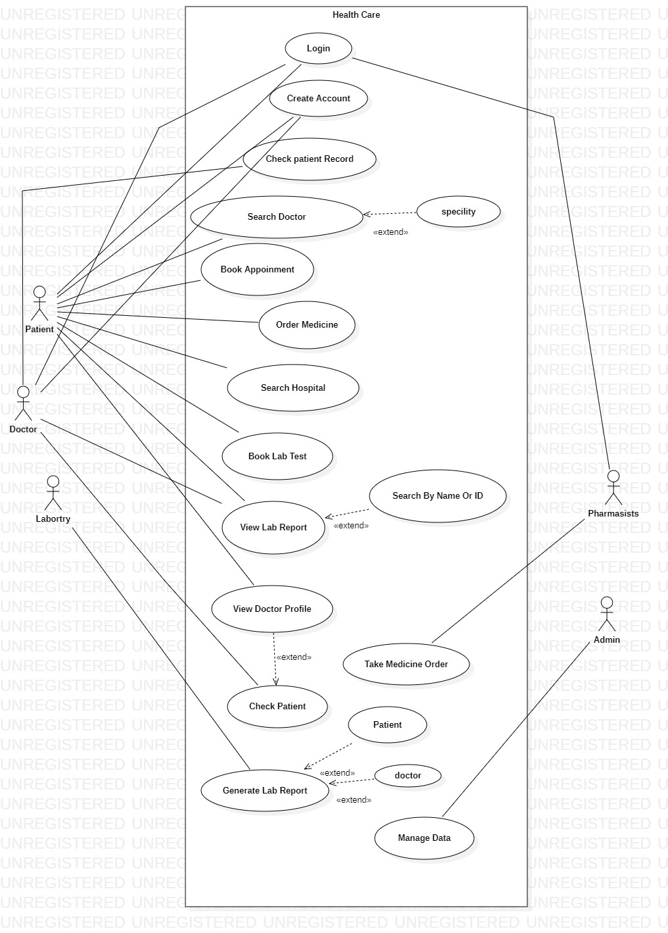

**Fully Dressed Use Case:**

|  |  |
| --- | --- |
| Name | Check Patient |
| Scope | Check patient on time |
| Level | User Goal |
| Actor | Doctor |
| Type | primary |
| Stakeholder and Interest’s | * **Patient**: Wants to checked by well experienced Doctor’s. * **Laboratory**: Will perform Patient test refer by the Doctor. * **Pharmacy**: Will Deliver Medicine to the Patient that’s prescribed by the doctor * **Payment Authorization**: Want to receive digital authorization requests in the correct format and protocol * **Government Tax Agencies**: Want to collect tax, it may be multiple agencies such as, national, state, country * **Company**: Wants accurately record of the patient Doctor laboratories and Pharmacies,   Satisfies Patient, Want to ensure that payment authorization recorded and want some fault tolerance in the system. |
| Main success Scenario | 1. Doctor will open the Application 2. Now Doctor will Provide Username and Password 3. System will verify the user 4. After verifying the User System will show the homepage 5. Now Doctor will open the check Patient List 6. Doctor will see the Scheduled and no of patients registered for appointment 7. There will be specific time for every patient 8. One by one doctor will check every patient 9. After all the patient is checked 10. Doctor will logout from the system |
| Alternate Flow | a*: Forget Password   1. If the user entered 3 times incorrect password. 2. System will pop up forget password dialogue 3. System will ask for option of verification i-e verify through Email or phone no. 4. User will select the option 5. System will send the verification code 6. User will enter the verification code 7. System will verify the verification code 8. System will ask for enter new password 9. after entering the new password system will prompt the user to the home page   b*: No internet Connection   1. if internet connection fails system should wait up to 10 sec to reconnect 2. System will ask the user to reconnect 3. User will check the internet connection and try again 4. After successful Connection the meeting is started from where it is stopped   C*: Failure in the system   1. System will ask to restart the application 2. If still not working 3. System will ask the user to update the application   D*: If patient is not available   1. If the patient is not available 2. Doctor will start meeting with the next patient 3. System will generate email to the patient about unavailability and about new date and time accordingly 4. System will generate email to the doctor too |
| Pre-Condition | * Doctor must Register to the system * Doctor must be login to the system * There should be a scheduled meeting |
| Post-Condition | * Give Feedback to the patient * Prescribe medicine to the patient * Check another patient if any * Logout from the system |
| Special Requirement’s | * System should response within second * System shall support 200 users at a time * Easy to use * System should secure the data of all user’s * Data should be saved for one year |
| Technology and data variations list | * User can login through Face lock * Use can login though finger print * Cross platform |

|  |  |
| --- | --- |
| Name | Book appointment |
| Scope | Fix checkup time with doctor |
| Level | User Goal |
| Primary Actor | Patient |
| Stakeholder | Patient, doctor |
| Pre-condition | * patient must Register to the system * patient must be login to the system * There should be a internet connection |
| Post-condition | * Give feedback to doctor * Logout from the system |
| Main Success Scenario | * User will enter username and password * System will validate it and show homepage * User will click on book appointment button * System will show list of specialty * User will select the required specialty * System will show list of doctor’s * User will select doctor from the list * System will show doctor profile * User will check the profile and click on book appointment * System will ask for payment * User will select payment method * System will verify the payment * System will send a conformation email to the user * System will show date and time of scheduled meeting |
| Alternate flow of Extension | a*: Forget Password   1. If the user entered 3 times incorrect password. 2. System will pop up forget password dialogue 3. System will ask for option of verification i-e verify through Email or phone no. 4. User will select the option 5. System will send the verification code 6. User will enter the verification code 7. System will verify the verification code 8. System will ask for enter new password 9. after entering the new password system will prompt the user to the home page   b*: No internet Connection   1. if internet connection fails system should wait up to 10 sec to reconnect 2. System will ask the user to reconnect 3. User will check the internet connection and try again 4. After successful Connection the meeting is started from where it is stopped   C*: Failure in the system   1. System will ask to restart the application 2. If still not working 3. System will ask the user to update the application   D*:invalid account detail   1. If user enter invalid account detail 2. System will ask for reenter the correct details 3. After user enter the correct detail 4. System will verify it and send conformation email to the user   E*:insufficient balance:   1. If the amount is insufficient 2. System will ask user to enter other account details 3. System will verify it and proceed its conformation |
| Special Requirement | * System should response within second * System shall support 200 users at a time * Easy to use * System should secure the data of all user’s * Data should be saved for one year |
| 1Technology and data variation | * User can login through Face lock * Use can login though finger print * Application should work on cross platform |

**Brief Use Case:**

|  |  |
| --- | --- |
| Use Case | Login |
| Actor | Doctor, Patient, Pharmacists, Lab Assistant |
| Type | Primary |
| Description | 1. System Request the Actor to enter the user name and password 2. User enter the user name and password 3. The system validate the user name and password, and show home page |

|  |  |
| --- | --- |
| Use Case | Create Account |
| Actor | Doctor, Patient, Pharmacists, Lab Assistant |
| Type | Essential |
| Description | 1. User Click on Create Account Button 2. System will show the Registration Form and ask the user to fill it accordingly 3. User will fill the from and submit it 4. System will send a verification email to user and the user will registered to the system |

|  |  |
| --- | --- |
| Use Case | Check Patient Record |
| Actor | Doctor |
| Type | Primary |
| Description | 1. Use will enter username and password 2. System will validate the user and show homepage 3. User will select the check patient record 4. System will show list of patient 5. User will select the patient for which user want to check his medical report 6. System will show his all medical report |

|  |  |
| --- | --- |
| Use Case | Search Doctor |
| Actor | Patient |
| Type | Primary |
| Description | 1. User will enter username and password 2. System will verify the username and password. After validation system will show home page 3. User will click on Search Doctor Button 4. System will show list of doctor and search option 5. User will search for any doctor 6. System will show doctor |

|  |  |
| --- | --- |
| Use Case | Order Medicine |
| Actor | Patient |
| Type | Primary |
| Description | 1. User will enter username and password 2. System will verify the username and password. After validation system will show home page 3. User will click the Order Medicine button 4. System will show list of medicine with discounts 5. User will select the medicine and put it to cart 6. After completion the system will ask for payment 7. User will select the payment method and pay |

|  |  |
| --- | --- |
| Use Case | Search Hospital |
| Actor | Patient |
| Type | Primary |
| Description | 1. User will enter username and password 2. System will verify the username and password. After validation system will show home page 3. User will click on Search Hospital Button 4. System will show list of Hospital’s and search option 5. User will search for any Hospital 6. System will show Hospital profile |

|  |  |
| --- | --- |
| Use Case | Book Lab Test |
| Actor | Patient |
| Type | Primary |
| Description | 1. User will enter username and password 2. System will verify the username and password. After validation system will show home page 3. User will click on the book lab test button 4. System will show list of laboratory 5. User will select the laboratory 6. System will show further detail of that laboratory 7. User will select the test type. 8. System will ask for payment method 9. User will select the payment method 10. System will send the conformation email along with unique id to user |

|  |  |
| --- | --- |
| Use Case | View Lab Report |
| Actor | Patient, Doctor |
| Type | Primary |
| Description | 1. User will enter username and password 2. System will verify the username and password. After validation system will show home page 3. User will click on the view lab report button 4. System will show list of laboratory 5. User will select the laboratory in which user booked the test 6. System will ask for unique id 7. User will enter unique id 8. System will validate the id and show report 9. Also system will prompt for view and download option |

|  |  |
| --- | --- |
| Use Case | View Doctor Profile |
| Actor | Patient |
| Type | Primary |
| Description | 1. User will enter username and password 2. System will verify the username and password. After validation system will show home page 3. User will click on Search Doctor Button 4. System will show list of doctor and search option 5. User will search for any doctor 6. System will show doctor profile |

|  |  |
| --- | --- |
| Use Case | Take Medicine Order |
| Actor | Pharmacists |
| Type | Primary |
| Description | 1. User will enter username and password 2. System will verify the username and password. After validation system will show home page 3. User will click on view medicine order Button 4. System will show the different order from different patient 5. User will take order and dispatch it to the given address |

|  |  |
| --- | --- |
| Use Case | Generate lab report |
| Actor | Lab Assistant |
| Type | Primary |
| Description | 1. User will enter username and password 2. System will verify the username and password. After validation system will show home page 3. User will click on the view book lab report button 4. System will show list of booked lab test 5. User will select the patient with their unique key 6. User will upload the lab report 7. System will ask for permission 8. User will verify it 9. System will upload it |

|  |  |
| --- | --- |
| Use case | Manage Data |
| Actor | Admin |
| Type | Primary |
| Description | 1. User will enter username and password 2. System will verify the username and password. After validation system will show home page 3. Now user can accept the request of new doctor patient lab assistant pharmacists 4. User can update the Record 5. User can reset password for other user |

**Concrete classes:**

There are the following concrete classes in our project:

* Doctor
* Patient
* Hospital
* Admin
* Pharmacy
* Medicine
* Pharmacist
* Lab attendant
* Laboratory
* Lab report
* Receptionist

**Domain Model:**

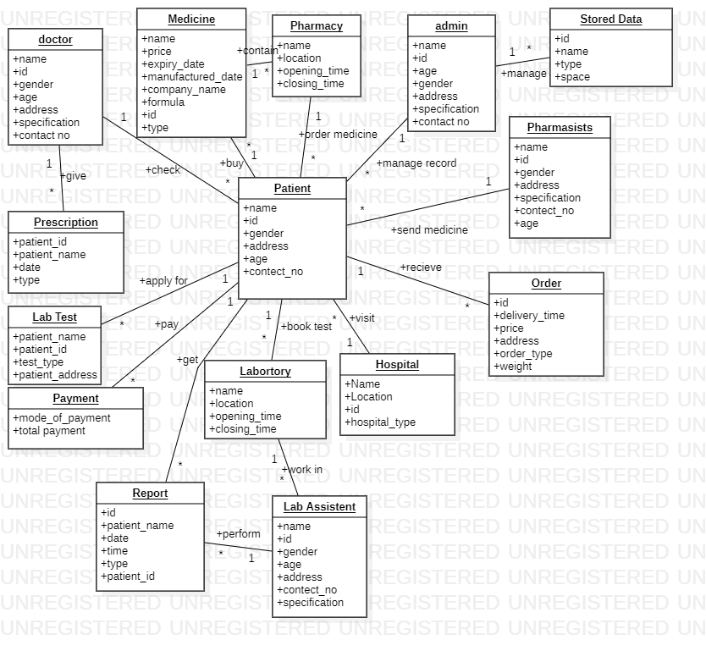

**Class Diagram:**

